Bangladesh Army University of Engineering & Technology (BAUET)
Qadirabad Cantonment, Natore-6431



Proposal for Project
On
NexaLib
A Smart University Library Management System

Submitted By: | Submitted To:
Name:Mst. Rizoana Khatun  ID: 0812220105171005 | Supervisor Name: Sudipto Saha  Designation: Lecturer
Student of Batch:13th | Department: ICE
Course Code: ICE-4232 | Credit Hours: 1.5hr
Course Title: Software Engineering Sessional | Date of Submission:01/10/2026
Academic Semester:8th
Remarks

Date & Signature of Evaluator

Department of Information and Communication Engineering (ICE)

Table of Contents

1. Introduction 3
2. Review of existing work 3
3. Critical Analysis and Problem Statement 5
4. Objectives 6
5. Project Explanation 6
6. Expected Outcome 6
7. Milestone 7
8. Budget 7
9. Conclusion 8
10. Reference 8
11. Declaration 9

Introduction
- NexaLib is a modern University Library Management System designed to simplify and automate daily library operations.
- The system provides a centralized platform to manage books, members, borrowing, returning, reservations, and fines.
- It helps librarians efficiently track book availability, loan records, overdue books, and member information.
- Search, filtering, and sorting features make it easier to find books and manage large amounts of information.

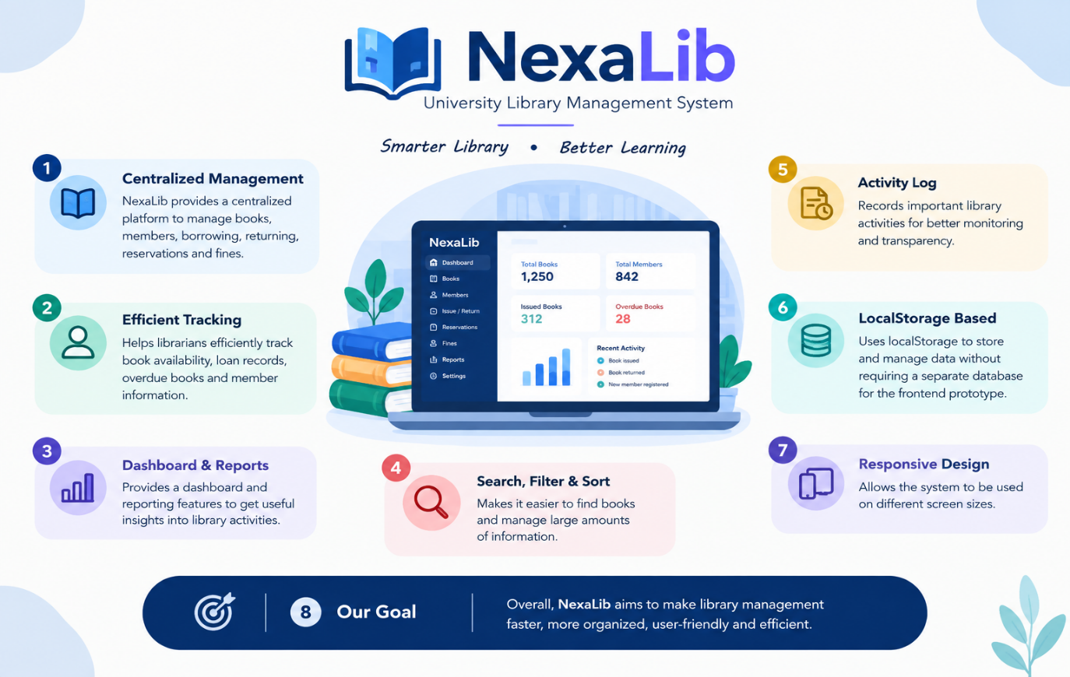
Figure 1: Land Use and Land Cover (LULC) Classes.[1]

Review of existing work
- Yip Lik Zeh and Noryusliza Abdullah (2023) developed a web-based Library Management System to improve the efficiency of library operations. The system was designed to replace manual processes used for book inventory, borrowing records, and overdue penalties. The proposed system focused on important library functions such as book availability checking, inventory management, borrowing records, and overdue management. The study demonstrated that a web-based approach can simplify daily library operations and provide more efficient access to library information. The work highlights the importance of automation in reducing manual effort and improving library service efficiency.[1]
- Jahidur Rahman (2023) proposed a web-based Library Management System as a centralized platform for managing library resources and services. The system focused on cataloging and organizing library resources, improving book searching, and supporting online access to library information. The study also discussed the possibility of allowing users to explore collections remotely and place holds on desired materials. The work demonstrates how web-based systems can improve accessibility and streamline traditional library operations.[2]
- Camila et al. (2023) developed a web-based library management system integrated with Quick Response (QR) technology for the Iriga City Public Library. The system aimed to automate library administration and improve the management of library resources. QR technology was incorporated to provide a more efficient method of identifying and managing library materials. The study demonstrates that integrating identification technologies with web-based library systems can reduce manual work and improve the efficiency of library services.[3]
- Aliyu et al. (2024) proposed a Smart QR-Based Library Management System to provide a user-friendly and efficient approach to managing library materials. The system used QR codes to support important operations such as issuing, returning, and managing library resources. The authors reported that QR-based automation can reduce the time, effort, and human resources required for traditional library management. The system also maintained an audit trail and improved user accessibility. The study demonstrates the potential of QR technology for developing smarter and more accessible library management systems.[4]
- Rahmawati and Marselina (2024) implemented a Library Management System using SLiMS 9 Bulian with QR Code integration. The study addressed problems associated with manual borrowing, returning, and collection management in a school library. The researchers used the Rapid Application Development (RAD) methodology to develop the system. QR Code integration was introduced to improve the functionality of the library system and make collection and service management more efficient. The study shows that combining an established library management platform with QR technology can improve library service automation.[5]
- Zhou (2024) proposed a smart library architecture based on Internet of Things (IoT) and Software-Defined Networking (SDN). The study explored how IoT technologies can be integrated into library environments to support smarter resource management and library services. The architecture focuses on connecting library-related devices and services through an intelligent network infrastructure. The work demonstrates how emerging technologies such as IoT and SDN can provide a foundation for more connected and intelligent library environments.[6]
- Bakhar et al. (2025) developed a website-based Library Information System to improve the efficiency and accuracy of library management. The system was developed using the Waterfall methodology, with PHP as the programming language and MySQL as the database. Major features included book borrowing and returning, book and member management, and customized dashboards for administrators and users. The system was tested using black-box testing, and the results indicated that the implemented functions operated according to the specified requirements. The study demonstrates the effectiveness of web-based systems for improving information retrieval and routine library operations.[7]

Critical Analysis and Problem Statement
Recent studies have demonstrated significant progress in library management systems through web-based platforms, QR technology, and smart-library architectures. Zeh and Abdullah (2023) developed a web-based Library Management System to manage book availability, inventory, borrowing records, and overdue penalties, demonstrating the benefits of replacing manual library operations with a centralized system. Rahman (2023) proposed an online library management solution focusing on centralized library information and improved accessibility. Camila et al. (2023) introduced a web-based public library system integrated with QR technology to improve library administration and circulation processes. Aliyu et al. (2024) further explored QR-based library management for handling library materials and reducing manual effort during circulation. Rahmawati (2024) implemented an LMS using SLiMS 9 Bulian, QR Code, and Rapid Application Development (RAD), addressing inefficiencies in manual borrowing, returning, and collection management. Zhou (2024) proposed a smart-library architecture integrating IoT, SDN, and RFID to support automated library management, although such technologies require more complex infrastructure and implementation. More recently, Bakhar et al. (2025) developed a website-based library information system using PHP and MySQL with book/member management, borrowing/returning, dashboards, and black-box testing, demonstrating the practicality of conventional web technologies for library automation. Overall, these studies show that web-based systems, QR technology, RFID, IoT, and smart-library architectures can improve the efficiency, accessibility, and accuracy of library operations, but many existing systems are designed for specific school or public-library environments or introduce additional technological and infrastructure complexity. Therefore, this research proposes NexaLib, a university-focused Library Management System that integrates book and member management, issue/return, reservations, fine calculation, dashboards, reports, and activity monitoring using a practical web-based architecture with HTML, CSS, JavaScript, PHP, and MySQL.
Problem Statement
- Manual Management: Traditional library processes are time-consuming and may lead to errors in managing books, members, and borrowing records.
- Difficult Tracking: Tracking book availability, overdue books, returns, reservations, and fines efficiently can be challenging.
- Limited Accessibility: Manual systems often lack centralized information, quick search, reporting, and real-time activity monitoring.

Objectives
- Automate Library Operations: Develop a centralized system to efficiently manage books, members, borrowing, returning, reservations, and fines.
- Improve Tracking & Accuracy: Provide effective tracking of book availability, overdue records, and fine calculations while reducing manual errors.
- Provide Easy Access & Monitoring: Implement search, dashboard, reports, and activity logs to make library management faster and more user-friendly.

Project Explanation
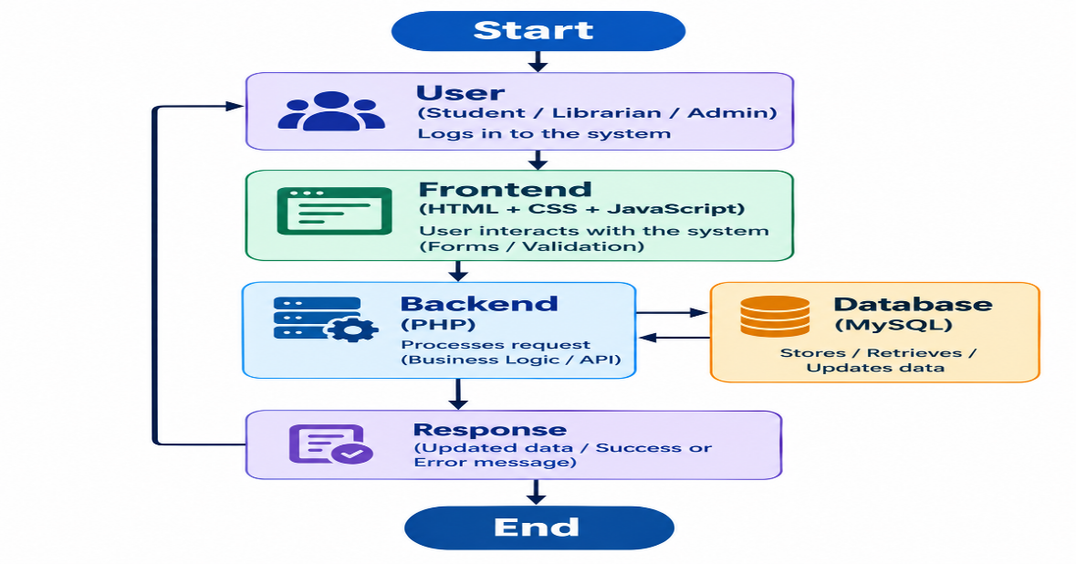
Figure 2: Overall Proposed System Flow of the NexaLib Library Management System

Expected Outcome
- Efficient Library Management: A centralized system will simplify the management of books, members, borrowing, returning, reservations, and fines.
- Accurate & Faster Operations: Automated record management and fine calculation will reduce manual errors and save time.
- Easy Monitoring & Reporting: Search, dashboard, reports, and activity logs will provide quick access to important library information and improve overall monitoring

Milestone
Table 3: Timeline of project

Activity | M1 | M2 | M3 | M4 | M5 | M6
Literature Review & Requirement Analysis
UI/UX Design & Frontend
Development

PHP Backend Development

MySQL Database Design &
Integration

System Integration &
Feature Implementation

Testing, Debugging &
Optimization

Final Testing,
Documentation &
Presentation

Budget
Category | Description | Estimated Cost (BDT)
Computing | Development, testing, and system integration support | 1500
Internet and Data Access | Research, documentation, online resources, and development support | 800
Storage / Backup | Project files, database backup, and documentation storage | 400
Software / Tools | Development and analysis support | 300
Printing & Binding | Proposal, final report, and presentation materials | 1000
Miscellaneous | Other academic project expenses | 1000
Total | Approximate project budget | 5,000
In Word: Five thousand only.

Conclusion
NexaLib provides a centralized and user-friendly solution for managing university library operations. The system integrates HTML, CSS, JavaScript, PHP, and MySQL to manage books, members, issue/return, reservations, fines, and reports efficiently. By reducing manual work and organizing library data in a structured way, NexaLib can improve the accuracy, accessibility, and efficiency of library management. The system can also be further extended with additional features and security improvements in the future.

Reference
[1]Y. L. Zeh and N. binti Abdullah, “Development of Library Management System using Web-Based Approach,” Applied Information Technology and Computer Science, vol. 4, no. 1, pp. 346–364, 2023.
[2] J. Rahman, “Library Management System: A Complete Solution for an Online Library,” 2023.
[3] D. P. Camila, A. N. A. Daban, and M. E. C. Odiada, “Web-based Iriga City Public Library Management System with QR Technology,” Undergraduate Thesis, Camarines Sur Polytechnic Colleges, 2023.
[4] M. Aliyu, L. Mohammed, and I. Z. Yakubu, “A Smart QR: Based Library Management System,” International Journal of Innovative Science and Research Technology, vol. 9, no. 10, 2024. doi: 10.38124/ijisrt/IJISRT24OCT212.
[5] M. Rahmawati, “Implementasi Library Management System (LMS) Menggunakan SLiMS dengan Metode Rapid Application Development (RAD),” Jurnal Informasi dan Komputer, vol. 12, no. 1, 2024. doi: 10.35959/jik.v11i02.339.
[6] Q. Zhou, “Smart library architecture based on Internet of Things (IoT) and Software Defined Networking (SDN),” Heliyon, vol. 10, no. 3, p. e25375, 2024. doi: 10.1016/j.heliyon.2024.e25375.
[7] M. Bakhar, M. S. Sungkar, and U. Albab, “Website-based Library Information System at SMK Muhammadiyah Adiwerna,” Jurnal Informasi dan Teknologi, vol. 7, no. 3, pp. 39–44, 2025. doi: 10.60083/jidt.vi0.672

Declaration
We are declaring that this proposal is original and not submitted anywhere else.

Signature & Date
Name: Mst. Rizoana Khatun
ID: 0812220105171005

